OUTPUT SCREENS
JUnitBasicTesting-Ex1
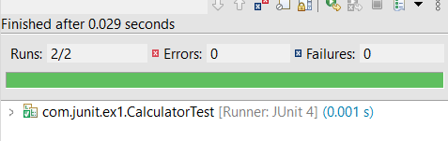

JUnitBasicTesting-Ex3
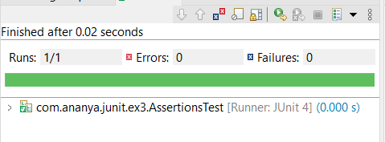

JUnitBasicTesting-Ex4
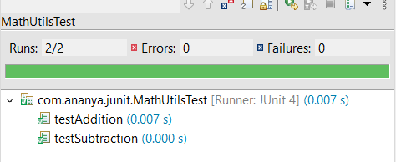

LoggingExampleAppEx-1

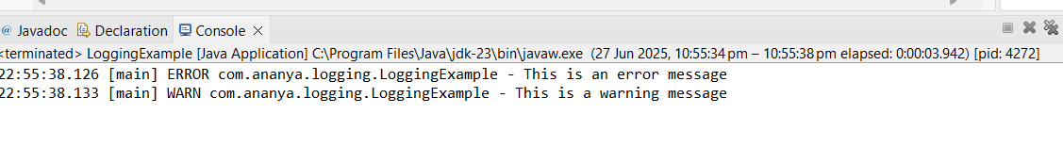
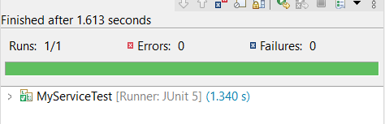
MockitoTesting-Ex1

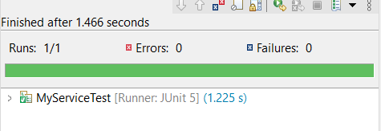
MockitoTesting-Ex2
